
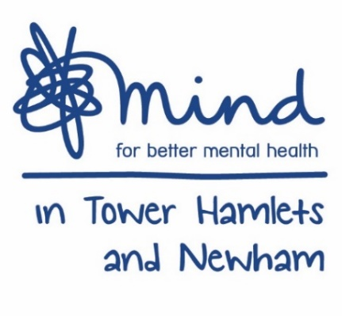
CONFIDENTIAL
Today’s date: |  |  | Client requested support: Yes No

CLIENT INFORMATION
Client’s forename/s: |  |  |  | Client’s Surname:
Birth date: |  | Age: |  | Gender: Male Female Transgender Other Prefer not to say
Address:
 |  |  |  |  |  |  |  |  | Post Code:
Primary Contact Number: |  |  |  |  | Email address:
Relationship to deceased:
Reason for referral:

Any previous experience of counselling?

Any previous psychiatric diagnosis, mental health treatment or special needs?

Any episode of suicidal thoughts or any attempts made?

Service needs:
Counselling Group Support Advice and Information
Referred to service area:
Date referred:

DECEASED INFORMATION
Name: |  |  |  |  | Date of death:
Circumstances of death:

Address:
 |  |  |  |  |  |  |  | Postcode:

Referrer details
Name:
Address:
 |  |  |  |  |  |  |  | Postcode:
Relationship to client:
Telephone no.: |  |  |  |  |  | Email:
GP details if different from above:
Name:
Address:
 |  |  |  |  |  |  |  | Postcode:
Telephone no.: |  |  |  |  |  | Email:
Please indicate Client’s Ethnicity
Asian British Bangladeshi  Asian British Indian  Asian British Pakistani  White & Asian | Asian British  Other Asian Background  Black British African  Black British Caribbean |  |  | Black British Somali  White and Black African  White and Black Caribbean  Other Black Background  Black British  Other Mixed background |  |  | White British  White Irish  White Lithuanian  White Polish  White Romanian  White Bulgarian |  |  | Gypsy/Traveler  Other White background  Chinese  Vietnamese  Other  Not Known  Not Asked
PLEASE INDICATE CLIENT’S RELIGION
Buddhist  Sikh | Christianity  Muslim |  |  | Hindu  Other |  |  | Jewish  Prefer not to say |  |  | No Affiliated Religion Background
PLEASE INDICATE CLIENT’S DISABILITY
Deafness /partial loss of hearing  Blindness /partial loss of sight | Learning Disability  Learning Difficulty |  |  | Physical Disability  Developmental disability Other |  |  | Long Term Illness  Other |  |  | Prefer not to say  No
PLEASE INDICATE CLIENT’S SEXUALITY
Heterosexual | Bisexual |  |  | Gay |  |  | Lesbian |  |  | Other  Prefer not to say
PLEASE INDICATE CLIENT’S PREGNANCY CARER?
Pregnant | On Maternity Leave |  |  | Returning from Maternity Leave |  |  | Other |  |  | Yes  No

PLEASE POST or EMAIL TO:
ADDRESS: 655 Barking Road, London, E13 9EX
TEL: 0207 510 1081 / 0207 510 4268
EMAIL: referral@mithn.org.uk
FOR BEREAVEMENT SERVICE USE ONLY:
Logged:
Initial Assessment:
Volunteer assigned:
Referred to Advice and information:
Referred to group support:

