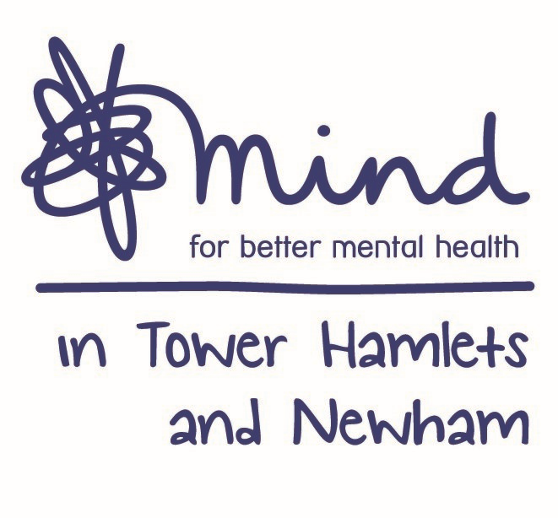

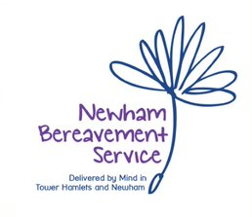

**Advert: Counselling Coordinator - Newham Bereavement Service**

**Hours:** 21 Hours per week (days and times negotiable although there may be evening and weekend work)

**Salary:** NJC scale point 20-24, currently £28,837 - £31,447, per annum inclusive of Inner London Weighting (Pending NJC Living Cost Allowance). Based on 21 hrs. per week this is equivalent to £17, 301 based on NJC scale point 20.

**Location:** Newham (Currently all staff working remotely)

**Contract:** Currently until the 31st July 2021 with possible extension

**Closing Date: 5pm Wednesday 27th October 2020**

**Interviews Held on: Between Wednesday 4th and Thursday 5th November 2020**

Mind in Tower Hamlets and Newham is seeking to recruit a Counselling Coordinator to oversee project coordination, support and delivery of the Newham Bereavement Service.

You must have a Psychotherapy/Counselling Qualification (Diploma minimum), together with substantial experience of providing counselling. You should have accredited membership of the UKCP/BACP or BCP or prepared to work towards this within the first six months.

You will have demonstrable experience of working in the voluntary/statutory sector ideally in a project coordination/management role within a clinical setting. You must have excellent planning and organisation skills as well as the ability to work in a pressurized environment and prioritise workloads.

You must have experience of carrying out assessments including clinical assessments, staff supervision and recruitment of Clinical Placement Volunteers and paid counsellors. You will have the ability to communicate with a diverse range of people who may be experiencing bereavement including those who have been recently bereaved. You should be able to demonstrate that you are able to keep clear and concise notes and prepare written reports of a high standard as well as maintaining client database systems. Working closely with the Operational Director you will help develop the service in line with contract requirements.

Benefits include training, Employee Assistance Programme, Company Pension and 30 days annual leave.

Post subject to an enhance Disclosure Barring Service check. Applications welcome from all sections of the community.

Please note that we do not accept CV ‘s

**For an application pack, please email:** [**recruitment@mithn.org.uk**](mailto:recruitment@mithn.org.uk) **quoting job ref: NBSCC2020**