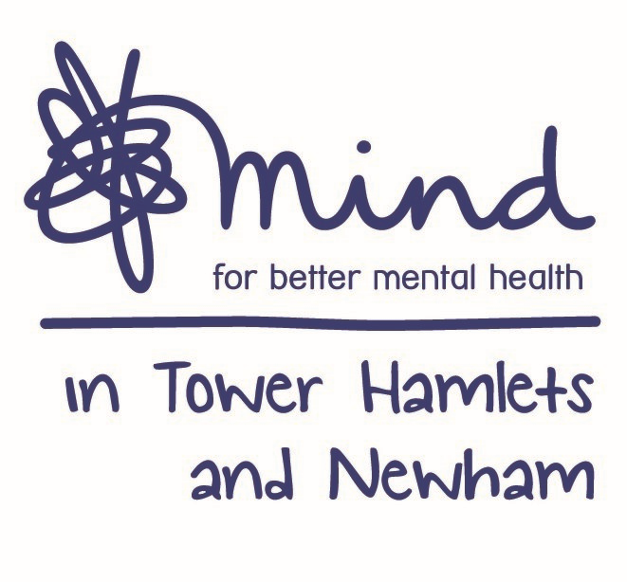

**Advert: Counselling Coordinator**

**Hours:** 35 Hours per week (days and times negotiable although there may be evening and weekend work)

**Salary:** NJC scale point 20-24, currently £28,837 - £31,447, per annum inclusive of Inner London Weighting (Pending NJC Living Cost Allowance)

**Location:** Currently all staff working remotely (this is subject to changes)

**Contract:** Full Time

**Closing Date:** 5pm Tuesday 10th November 2020

**Interviews Held on:** Wednesday 18th and Thursday 19th November 2020

Mind in Tower Hamlets and Newham is seeking to recruit a Counselling Coordinator to oversee project coordination, support and delivery of the Newham Bereavement Service.

You must have a Psychotherapy/Counselling Qualification (Diploma minimum), together with substantial experience of providing counselling. You should have accredited membership of the UKCP/BACP or BCP or prepared to work towards this within the first six months.

You will have demonstrable experience of working in the voluntary/statutory sector ideally in a project coordination/management role within a clinical setting. You must have excellent planning and organisation skills as well as the ability to work in a pressurized environment and prioritise workloads.

The Counselling Coordinator will have high levels of professionalism, strong leadership with excellent organisational skills. You will have a strong ability to co-ordinate and oversee the range of activities as part of the IAPT contract for Talking Therapies. You will have excellent ability in the use of IAPTus or similar patient database system for client record keeping and navigation of clinical pathways. You must have experience of recruiting and supporting a team of counsellors to ensure they achieve high standards of clinical practice in their delivery.

Benefits include training, Employee Assistance Programme, Company Pension and 30 days annual leave.

Post subject to an enhance Disclosure Barring Service check. Applications welcome from all sections of the community.

Please note that we do not accept CV ‘s

**For an application pack, please email:** [**recruitment@mithn.org.uk**](mailto:recruitment@mithn.org.uk) **quoting job ref: THTTCC2020**