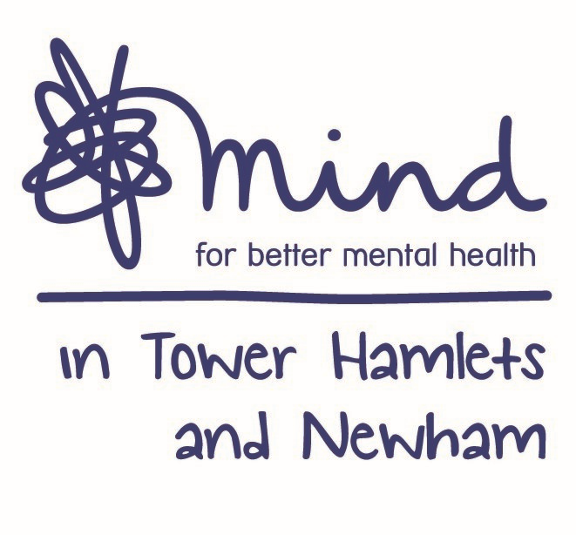

**Advert: Operations Director – Mind in Tower Hamlets and Newham**

**Hours:** 28 Hours per week (days and times negotiable although there may be evening and weekend work)

**Salary:** NJC scale point 34-38, currently £41,432 - £45,423, per annum inclusive of Inner London Weighting. On 28 hrs per week this is equivalent to £33,146 based on NJC scale point 34.

**Location:** Tower Hamlets and Newham (Currently all staff working remotely)

**Closing Date: 5pm Friday 18th December 2020**

**Interviews Held: Thursday 7th January 2021**

Mind in Tower Hamlets and Newham is a vibrant organisation. We have positioned ourselves as a leader in innovative good practice and won several awards for our progressive work. As a specialist mental health organisation we provide a range of services including mental health, advocacy, talking therapies, employment and advice and information. We have grown considerably in the last 3 years and expanded our geographical reach to include the borough of Redbridge.

An exciting opportunity has arisen for the position of Operations Director, where you will join our dynamic and diverse team of staff to support the strategic and operational direction of the organisation. The ideal candidate will share our vision and future ambitions to help us achieve our goals.

To meet the requirements for this role, you must:

* Be qualified to a minimum degree level and preferably hold a professional qualification, although this is not essential.
* Have excellent project management experience and strong leadership skills to effectively oversee a range of projects across our talking therapies and employment services.
* Be agile with the ability to respond to changing environments through your understanding of economic, social, legislative, and political factors affecting mental health
* Be creative with the ability to offer practical solutions in the development and design of new services and implement improvements where needed.
* Have demonstrable experience of working in the voluntary/statutory sector ideally in a project management role within the field of mental health
* Have excellent planning and organisation skills as well as the ability to work in a pressurized environment and ability to prioritise workloads.
* Experience of producing high quality reports to a range of audiences and the necessary verbal, written and IT literacy skills
* Be able to develop and maintain strong partnerships to enhance existing and future relationships
* Understand budget and resource management
* An understanding and commitment to equal opportunities, anti-racist and anti-discriminatory practices

Benefits include training, Employee Assistance Programme, Company Pension and 30 days annual leave.

This Post is subject to an Enhanced Disclosure Barring Service check and eligibility to work in the UK. Applications welcome from all sections of the community.

The preference is for application-based submissions; however, we will accept CV’s. if they meet the requirements for the role.

**For an application pack, this can be downloaded via our website:** [**https://www.mithn.org.uk/get-involved/work-for-us/**](https://www.mithn.org.uk/get-involved/work-for-us/)**, alternatively you can email:** [**recruitment@mithn.org.uk**](mailto:recruitment@mithn.org.uk) **quoting job ref: OD2020**