

### 

### Project Coordinator

### JOB DESCRIPTION

### Job Title: Project Coordinator – LEAP

**Grade:** NJC Scale point 20, currently £29,533 per annum including ILW

**Accountable to:**  Operational Director

**Office Base:** Open House – 13 Whitethorn Street, London E3 4DA but will be required to work across the London Boroughs of Newham and Redbridge

**Hours** 35hrs per week (may include some weekends and evenings)

**Contract Term:** Funded until July 2022

**Management Structure**

Mind in Tower Hamlets and Newham staff are accountable to the CEO. The Project Coordinator for the LEAP will be supervised by the Operational Director who reports to the CEO.

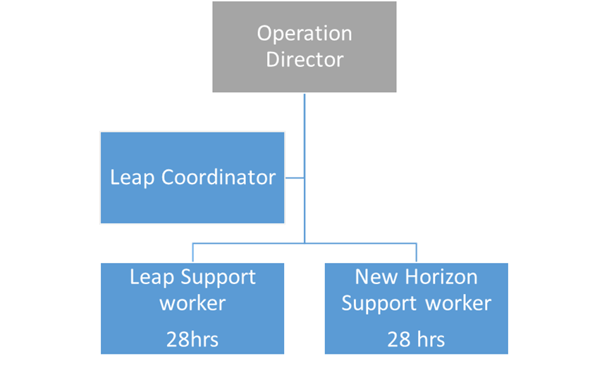

**Background Information**

The LEAP Peer Leadership programme provides training and supports to people with lived experience of mental health, to become Community Peer Leaders (PL’s). With training and support they will facilitate and develop their own creative and independent social community groups (CG’s) within their local communities across the London Boroughs of Tower Hamlets, Newham and Redbridge. This project is funded for 18 months and the role is suited to somebody with a dynamic and creative personality who is committed to user involvement, co-production and understanding of the value of Peer Led groups in improving quality of life and mental wellbeing.

# Overall Purpose of the Post

The purpose of this post is to develop and maintain good promotion and recruitment of PL’s and develops a programme of activities, ensuring respect and sensitivity to users’ customs, values and spiritual beliefs at all times. The Coordinator will have the responsibility of supervising the LEAP and New Horizons Support Workers

**Key Responsibilities**

1. Recruit and train prospective Peer Leaders with lived experience of mental health that reflect and best represent the demographic of that borough as well as ensuring individual risk assessment and risk management plans are carried out, actively identifying needs and areas for additional support.
2. To widely promote the service to people with lived experience, organisations including mental health, homelessness and youth services, encouraging participation and building a network of peer support that includes strong partnerships within the community.
3. To deliver mental health awareness training workshops to local organisations, business to ensure our commitment to challenging the stigma related to mental health.
4. Develop, deliver and facilitate a programme of training to enable ongoing continuous development for Peer Leaders as well as their own portfolio of personal achievements
5. Provide on-going support to Peer Leaders in order to maintain their commitment to the programme
6. To develop a network of peer support activities for people with lived experience to access
7. Support the Operational Director in the development and implementation of strategies and plans in order to meet project aims and outcomes.
8. Provide project coordination and support the implementation plan ensuring that activities and tasks are carried out within the agreed timeframe.
9. Work with the team to support Peer Leaders in the development, design and facilitation of activities as well as the implementation of any policy/procedural documents/guidelines/systems which enables them to function with a greater degree of independence incorporating good practice in facilitation and leadership
10. Undertake any relevant risk assessments and health and safety checks involving the activity
11. Provide direct supervision of the support staff, with the ability to effectively incorporate remote management styles to ensure regular communication and support throughout
12. Develop and maintain effective systems for ensuring feedback and monitoring from users to influence and guide both practice and activity within the project
13. To prepare and complete the required reporting templates in a timely fashion in conjunction with the Operations Director.
14. Learn and be able to put into practice de-escalation techniques, responding calmly to potentially disruptive incidents and seeking assistance when required

## Administration, Promotion and Partnerships

1. To be responsible for ensuring that the marketing strategy is maintained and updated and ensuring good promotion and publicity of the project both within the service and the wider community through a range of various communication channels and awareness events/activities
2. Develop strong partnerships with both the voluntary and statutory sector
3. Ensure that regular staff meetings are held to ensure involvement of staff and Peer Leaders in planning and evaluating the project
4. Maintain statistical information and provide clear and accurate reports and data as and when required and requested by the Operational Director
5. Keep records of all expenditure and income received
6. Be administratively self-servicing
7. Flexible approach to work as the role may require you to work evenings

**Duties required of all Employees**

1. Undertake the induction programme as devised and assist in induction of new staff, if requested to do so
2. Attend and participate in staff meetings, team meetings, appraisals, training and other meetings as required
3. Undertake all duties in accordance with Mind in Tower Hamlets and Newham’s policies, with particular reference to the Equal Opportunities and Health and Safety policies to maximise safety of clients and staff.
4. Undertaking other duties and accepting special responsibilities to maintain or enhance the services delivered by Mind in Tower Hamlets and Newham
5. To effectively manage any petty cash or financial issues within the finance procedures laid down.
6. To carry out other duties consistent with the post

**This job will be reviewed periodically in line with the organisation’s Business Plan. Mind in Tower Hamlets and Newham aim to reach agreement on changes, but if agreement is not possible, Mind in Tower Hamlets and Newham reserves the right to change the job description**

**PERSON SPECIFICATION**

**Project Coordinator (LEAP and New Horizons)**

**E = Essential**

**D = Desirable**

|  |  |  |
| --- | --- | --- |
| **Experience** | | |
|  | Demonstrable experience of a recovery approach when working with people with Mental Health issues | E |
|  | Demonstrable experience of coordinating projects in the mental health, social care or homelessness sector to diverse communities | E |
|  | Experience of delivering and developing training programmes | E |
|  | Experience of co-producing user led groups or services | E |
|  | Demonstrable experience of establishing good working relationships with other provider organisations | E |
|  | Experience of supervising and developing staff and volunteers | E |
| **Knowledge** | | |
|  | Knowledge and awareness of the impact of mental health issues on individuals as well as the principles of recovery, resilience and wellbeing | E |
|  | Good knowledge of local services within the community including statutory and non-statutory services | E |
|  | Good understanding of models of good practice and national developments around co production and community development | D |
|  |  |  |
| **Abilities & Skills** | | |
|  | Self-starter who is enthusiastic, energetic and solution focused | E |
|  | Ability to work well under pressure and deal with conflicting demands | E |
|  | Excellent standard of written and spoken English | E |
|  | Ability to facilitate training sessions and groups | E |
|  | Ability to engage with the local providers and to work in partnership with other agencies | E |
|  | Ability to be fully self-servicing, including a high level of computer literacy and data management | E |
|  | Strong organisational skills and the ability to plan, prioritise and manage deadlines and workloads | E |
|  | Ability to carry out monitoring and evaluation activities as well as produce evaluation reports. | E |
| **General** | | |
|  | Ability to work flexibly. This may include some evenings | E |
|  | A respect for difference and an understanding of and commitment to  anti-discriminatory practices | E |
|  | The ability to work independently as well as be supported using remote management styles | E |