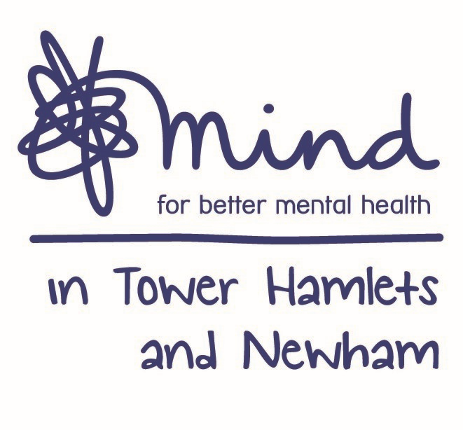

**Advert: Clinical Delivery Manager**

###### Post Title: Clinical Delivery Manager

**Grade:** NJC scale point 44, currently £52,761 per annum inclusive of Inner London Weighting

**Hours:** 35 hours, full-time

**Accountable to:** CEO, at Mind in Tower Hamlets and Newham,

**Supervised/Managed by:** ELFT Clinical Leads for Tower Hamlets Talking Therapies (THTT) and Newham Talking Therapies (NTT) And Mithn Operations Director

**Locations:** Tower Hamlets and Newham (Currently remote working due to Covid-19)

**DBS Check Required:** Enhanced

**Closing Date:** 5pm Friday 5th February 2021

**Interviews Held on:** Friday 12th February 2021

An exciting opportunity has arisen for the position of Clinical Delivery Manager, where you will join our dynamic and diverse team of staff to support the operational delivery of the Talking Therapies service. The ideal candidate will share our vision and future ambitions to help us achieve our goals.

Mind in Tower Hamlets and Newham is a local mental health charity based in East London providing a wide range of services to the local community including Advocacy, Employment Services, Welfare Benefits advice, and Counselling. Our counselling services are BACP accredited. This is an exciting time to join one of the largest counselling services across the Mind Network.

The Clinical Delivery Manager will work closely with the clinical leads from THTT and NTT in the preview of the current clinical model of delivery and service development to meet the Key Performance Indicators (KPIs) of the two sub-contracts. This has the potential to contribute to the further expansion of MITHN services by exploring new and innovative models of service delivery as well as supporting the continuous improvement and development of existing services.

The Clinical Delivery Manager role requires a high level of professionalism, strong leadership, and excellent organisational and management skills. You must be able to coordinate and oversee the provision of a range of counselling services across THTT and NTT in line with the specific contracts’ KPIs. You will also need to have a good understanding of the range of therapeutic modalities provided in each of the two services to overs the capacity planning, including the selection and recruitment of counsellors and counselling trainees.

The Clinical Delivery Manager will work closely with the clinical leads from THTT and NTT in the preview of the current clinical model of delivery and service development to meet the Key Performance Indicators (KPIs) of the two sub-contracts. This has the potential to contribute to the further expansion of MITHN services by exploring new and innovative models of service delivery as well as supporting the continuous improvement and development of existing services.

The Clinical Delivery Manager role requires a high level of professionalism, strong leadership, and excellent organisational and management skills. You must be able to coordinate and oversee the provision of a range of counselling services across THTT and NTT in line with the specific contracts’ KPIs. You will also need to have a good understanding of the range of therapeutic modalities provided in each of the two services to overs the capacity planning, including the selection and recruitment of counsellors and counselling trainees.

The Clinical Delivery Manager is accountable to the CEO and is supervised and managed by the Mithn Operations Director in partnership with ELFT clinical leads.

The successful candidate will have:

* Relevant Qualifications to HCPC registered Clinical or Counselling Psychologist /Cognitive Behavioural Therapist (Post Graduate Diploma level or above) with full BABCP accreditation/Qualified Counsellor/Psychotherapist with full UKCP or BACP accreditation
* Experience of working in an IAPT setting, or delivering treatment to primary care clients, liaising and consulting with GPs and community providers.
* Experience of either managing or coordinating wait lists.
* Experience of managing and supervising qualified therapists from different backgrounds.
* Work as an experienced psychologist/psychotherapist with advanced skills in at least one Psychological therapy modality.
* Excellence and experience in the continuous improvement of high and/or low intensity interventions and coordinating the services of a range of practitioners and providers, with experience of delivering this within primary care and or an IAPT compliant service.
* Experience of monitoring staff performance via case management; capacity management and monitoring staff recovery data.
* Experience of change management, service evaluation and service improvement.

We welcome applications from all sections of the community.

The post is subject to an enhanced Disclosure and Barring Service check

Benefits include training, Employee Assistance Programme, Company Pension and 30 days annual leave.

Post subject to an enhance Disclosure Barring Service check. Applications welcome from all sections of the community.

Please note that we do not accept CV ‘s

**For an application pack, please email:** [**recruitment@mithn.org.uk**](mailto:recruitment@mithn.org.uk) **quoting job ref: CDM2021**