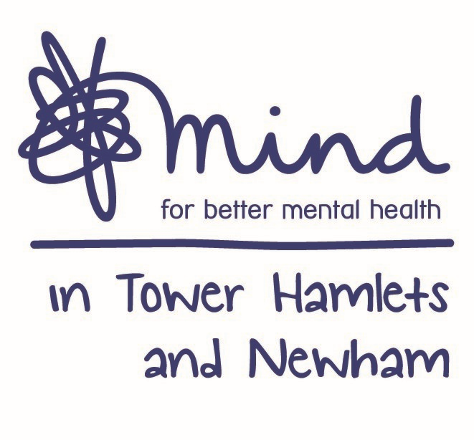

**Advert: Counselling Coordinator**

**Hours:** 28 Hours per week (days and times may be negotiable. There may be evening and weekend work). Job shares may be possible.

**Salary:** NJC scale point 20-24, currently £29,837 - £32,216, per annum inclusive of Inner London Weighting. At NJC scale point 20 for 28hrs, currently £23,704 per annum.

**Location:** Currently all staff working remotely. This is subject to changes, you may have a phased return to the MITHN office based on service needs

**Contract:** Part Time

**Closing Date:** 9am Monday 3rd May 2021

**Interviews Held on:** Wednesday 12th May 2021

Mind in Tower Hamlets and Newham is seeking to recruit a Counselling Coordinator to effectively support the coordination and supervise the activities of Tower Hamlets Talking Therapies and Newham Talking Therapies’ Counselling at an operational and clinical level to ensure that it meets its contractual obligations and KPI’s. Currently this service consists of bereavement counselling, brief counselling, and early bereavement support.

You must have a Psychotherapy/Counselling Qualification (Diploma minimum) or an IAPT Low intensity worker/Psychological Wellbeing Practitioner qualification, together with substantial experience of providing psychological interventions. It is desirable to have accredited membership of the UKCP/BACP or BCP or prepared to work towards this within the first six months.

You will have demonstrable experience of working in the voluntary/statutory sector ideally in a project coordination/management role within a clinical setting. You must have excellent planning and organisation skills as well as the ability to work in a pressurized environment and prioritise workloads.

The Counselling Coordinator will have high levels of professionalism, strong leadership with excellent organisational skills. You will have a strong ability to co-ordinate and oversee the range of activities as part of the IAPT contract for Talking Therapies. You will have excellent ability in the use of IAPTus or similar patient database system for client record keeping and navigation of clinical pathways. You should have experience of recruiting, inducting, case managing or line managing psychological therapists (paid or volunteers) and an ability to support a team of counsellors to ensure they achieve high standards of clinical practice in their delivery.

Benefits include training, Employee Assistance Programme, Company Pension and 30 days annual leave.

Post subject to an enhance Disclosure Barring Service check. Applications welcome from all sections of the community.

Please note that we do not accept CV ‘s

**For an application pack, please email:** [**recruitment@mithn.org.uk**](mailto:recruitment@mithn.org.uk) **quoting job ref: THTTCC2021**