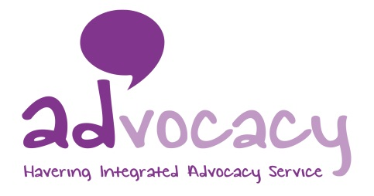

**Job Advert – RPPR Advocate (Havering)**

**Job Title:** RPPR Advocate

**Grade:** NJC SCP 14 currently £25,017 per annum - inclusive of OLW,

**Hours:** Full-time, 35 hours per week

**Accountable to:** CEO

**Supervised by:** Operational Director for Advocacy

**Location:** London Borough of Havering

**Contract Term:** Fixed term until March 2022

Mind in Tower Hamlets and Newham is a charity providing a wide range of services for residents including counselling, mental health support services, advocacy, and community engagement activities.

We now wish to recruit a Relevant Person’s Paid Representative (RPPR) advocate to be the named representative for people subject to a Deprivation of Liberty Safeguards (DoLS) order, as part of the Havering Integrated Advocacy Service.

The successful candidate will be an experienced advocate and will be able to demonstrate that they have the relevant skills and experience. Ideally you will hold the National Advocacy Qualification but if you do not hold this but have the relevant experience, you will be expected to work towards gaining this qualification.

You should have an understanding of the Principles of Advocacy, Human Rights Act, the Equality Act and the Mental Capacity Act, assisting clients to understand the effects of an authorisation of the deprivation of their liberty and to challenge the deprivation when necessary.

With substantial experience of good advocacy practice, you will be experienced in managing and maintaining a high caseload, ensuring regular visits and that reports are written in a timely manner.

With the ability to work as part of a team and on your own initiative prioritising and managing your own workload, you will possess excellent organisational and communication skills with the ability to communicate with professionals, residents and a wide range of people who may be distressed.

There are opportunities for training and benefits including: a company pension, 30 days’ annual leave pro-rated until the end of contract, a comprehensive E-Learning Programme and access to the Employment Assistance Programme (EAP).

This post is subject to an enhanced Disclosure and Barring Service Check.

**Closing date:** 9am, **16th August 2021**

**Applications welcome from all sections of the community**