
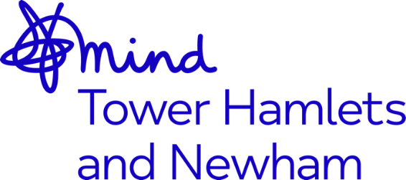

Job Advert: Peer Worker - Our Voices
Job Title: Peer Worker - Our Voices
Grade: NJC SCP 9 currently £24,543 per annum - inclusive of ILW. Based on 14 hrs per week, this is £9,817 per annum (inc ILW)
Hours: Part-time, 14 hours per week (may include some evenings and weekends)
Accountable to: Operations Director
Location: Tower Hamlets
Contract Term: 9 months, until 31st May 2022
Mind in Tower Hamlets and Newham is a charity providing a wide range of services for residents including counselling, mental health support services, advocacy, and community engagement activities.
This is a new role which will work collaboratively with the MITHN's Mental Health Services team to increase access to mental health and wellbeing support for Muslim women across Tower Hamlets, Newham, and Redbridge. The postholder will support the development and delivery of our program of in reach, access and engagement and work for seldom heard communities to co design and co-produce bespoke models of interventions with Muslim Women.
A key aspect for this role is an emphasis to enable Muslim women to have increase control and develop resilience in their recovery and to support them in a holistic way to better health and wellbeing.
The postholder will work with the Our Voices Team to successfully implement and support the delivery of the Our Voices project to set up a network of peer groups across the three boroughs and identify models of mental health and wellbeing that are culturally aware and appropriate for the client group. The post holder will work with local Muslim women and community groups to reduce the stigma and barriers to accessing support for women’s mental health and support the facilitation of peer support groups across the network. Our aim is to create "safe spaces" for Muslim women to share their challenges and experiences of mental health and wellbeing within their community, share their stories through the process of storytelling and listening to action.
There are opportunities for training and benefits including: a company pension, 30 days’ annual leave pro-rated until the end of contract, a comprehensive E-Learning Programme, access to the Employment Assistance Programme (EAP) and Death-In-Service benefits.
This post is subject to an enhanced Disclosure and Barring Service Check.
Closing date: 12noon, Monday 11th October 2021
Applications welcome from all sections of the community

