
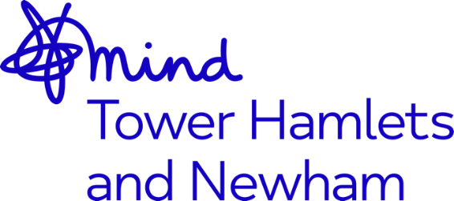

Job Advert: Peer Project Worker - Redbridge Mental Health Peer Project
Job Title: Peer Project Worker - Redbridge Mental Health Peer Project
Grade: NJC SCP 14 -20, currently £25,017 - £27,927 per annum, inclusive of Outer London Weighting
Hours: Full-Time, 37.5hrs. (may include some evenings and weekends)
Accountable to: CEO
Supervised By: Operations Director
Location: Redbridge
Contract Term: 24 months with potential extension to 3 years pending further funding
Closing Date: 12noon, Monday 18th October 2021
Mind in Tower Hamlets and Newham is a charity providing a wide range of services for residents including counselling, mental health support services, advocacy, and community engagement activities. We work with communities from diverse backgrounds and continually invest in building an inclusive organisational culture with diverse leaders through active Listening, Learning and Leading. Over the last 18 months we have explored racism and the impact that this has had on the lives of our clients and staff. This has resulted in the development of our strategic objective towards becoming an anti-racist organisation (ARO).
The Mental Health Peer Project Worker will provide support and recovery guidance to individuals experiencing common and severe mental health problems, using their own life experience of mental distress or as a carer and recovery as a template.
The Project Worker will be the key liaison between the NELFT Mental Health Wellness Teams, Team Manager, and the Peer Workers. They will be supported to guide and lead a team of 5 Peer Support Workers to ensure project aims and objectives are achieved. They will report to and be supervised by the Operational Director for MITHN. They will be tasked with supporting the team to develop recovery-based programmes for service users and members of the local community in partnership with statutory and community organisations.
The ideal candidate should have:
- NVQ Level 3 or equivalent standard of numeracy and literacy
- Lived Experience of Mental Health
- Knowledge of NHS and third sector mental health services
- Good understanding of Peer support and Recovery Approaches
- Experience of working with communities
- Strong leadership qualities and the ability to influence others towards achieving shared goals

There are opportunities for training and benefits including: a company pension, 30 days’ annual leave pro-rated until the end of contract, a comprehensive E-Learning Programme, access to the Employment Assistance Programme (EAP) and Death-In-Service benefits.
This post is subject to an enhanced Disclosure and Barring Service Check.
Closing date: 12noon, Monday 18th October 2021
Interviews: Thursday 21st October 2021
Applications welcome from all sections of the community

