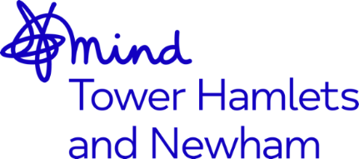


Mental Health Services Manager – Job Advert

Job Title: Mental Health Support Services Manager

Accountable to: CEO, Mind in Tower Hamlets and Newham

Responsible to: Operations Director, Mental Health Services

Responsible for: Tower Hamlets Recovery and Wellbeing Connecting Communities Service, North East London Safe Connections Community Hub

Working hours: Full-time 35 hours per week (Including some weekends and evenings)

Contract Term: 2 years

Salary: NJC SCP 30 – 36, currently £37,422 - £43,520 per annum inclusive of Inner London Weighting.

Based in: Tower Hamlets – 13 Whitethorn Street

Mind in Tower Hamlets and Newham are looking to recruit a Services Manager who has strong leadership and partnership skills with a passion for delivering high quality mental health and wellbeing services in line with our organisational values which are: Together, Unstoppable, Independent, Openness and Responsive.
We are looking for someone who can:
- Ensure that our clients are at the heart of everything we do.
- Work positively and collaboratively with other colleagues within the team
- Develop and maintain a good working relationship with key stakeholders and partners
- Commitment to the delivery of high-quality mental health services
- Has excellent organisational and communication skills
- Have a ‘can do’ attitude with a hands approach with dedication and commitment
- Committed to delivering and developing services that are equitable and accessible to the diverse communities in Tower Hamlets and Newham
- Manage all areas of performance related to contract management, including client experience and outcomes
This role is suitable for someone who is passionate about delivering mental health services that are at the heart of its communities and who manages with kindness and compassion.
The benefits of working for the organisation include 30 days annual leave, rising to 35 days after 5 years of service, training opportunities, good Company Pension Scheme, Death in Service Benefit and an Employee Assistance Programme
The post is subject to an enhanced Disclosure and Barring Service check.
We welcome applications from all sections of the community.
Closing date: 9am, 18th February 2022
Interview date: 24th and 25th February 2022

