**Project Manager – Newham Bereavement Service**

**Job description/Person Specification**

**Job Title:**  Project Manager – Newham Bereavement Service

**Grade:** NJC Scp 26 – 30, currently £34,090 to £37,422 per annum inclusive of Inner London Weighting. Based on 28 hours on NJC Scp 26 currently £27,272 per annum inclusive of ILW.

**Hours:** 28 hours per week

**Contract term:** To March 2023 (pending further funding agreement)

**Accountable to:** Chief Executive Officer (CEO)

**Supervised by:** Operations Director

**Main Location:** Newham

**About Mind in Tower Hamlets and Newham**

We are a local, registered charity affiliated to National Mind. The organisation supports those with mental health issues in Tower Hamlets, Newham and Redbridge towards recovery and leading a better life.

**Background**

We work with communities from diverse backgrounds and continually invest in building an inclusive organizational culture with diverse leaders through active Listening, Learning and Leading. Over the last 18 months we have explored racism and the impact that this has had on the lives of our clients and staff. This has resulted in the development of our strategic objective towards becoming an anti-racist organisation (ARO).

**Overview**

Mind in Tower Hamlets and Newham operate a range of services including Mental Health, Advocacy, Talking Therapies, Employment and Advice and Information. Click here to view our Annual Report: <https://view.pagetiger.com/annualreport2019/1>.

Mind in Tower Hamlets and Newham (MITHN) has a strong reputation for delivering high quality Talking Therapy services and achieving positive recovery outcomes.

MITHN is a BACP accredited service and operates in line with the BACP Ethical Framework for the Talking Therapy Professions as well as NICE guidelines. Our model of intervention incorporates both paid and Talking Therapy Placement Volunteers.

**Management Structure**

This role requires high levels of professionalism, excellent communication skills, strong leadership as well as the ability to manage projects and teams to achieve and maintain performance levels.

All Mind in Tower Hamlets and Newham staff are accountable to the Chief Executive Officer. The Project Manager will be supervised by the Operations Director who reports to the Chief Executive Officer. The Project Manager will have direct line management responsibility of paid Counsellors, clinical supervisors for bereavement clinical supervision, and have oversight of the Volunteer Talking Therapy Placements Counsellors.

The right candidate will be part of the Management Team and will support the Operations Director and the CEO in new service development that would enable us to expand the service, explore new and innovative models of service delivery as well as support the continuous improvement and development of existing services.

Our Counselling and Psychotherapy services are accredited by the British Association for Counselling and Psychotherapy (BACP). As an accredited service by the BACP, the Psychological Therapies team operate within the [Ethical Framework for the Counselling Professions](https://www.bacp.co.uk/media/2176/bacp-ethical-framework-for-the-counselling-professions.pdf).

**Purpose of the role:**

The Project Manager will work closely with the Operations Director to ensure the delivery of the NBS contract and delivery of the current clinical model, service development and the achievement of service Key Performance Indicators (KPIs).

The Project Manager role requires a high level of professionalism, strong leadership, and excellent organisational and management skills. You must be able to coordinate and oversee the provision of a range of activities and services within the Bereavement Service in line with contractual KPIs. You will also need to have a good understanding of the range of therapeutic modalities provided to oversee capacity planning, allocations including the selection and recruitment of counsellors and Counselling Volunteers.

The Project Manager will also have overview of the bereavement services delivered across the MITHN services in particular:

* Support for counsellors delivering early bereavement
* Development of training resources for counsellors and volunteers
* Development of Bereavement groups as well as the bereavement café

**Newham Bereavement Service Counselling Model from October 2021.**

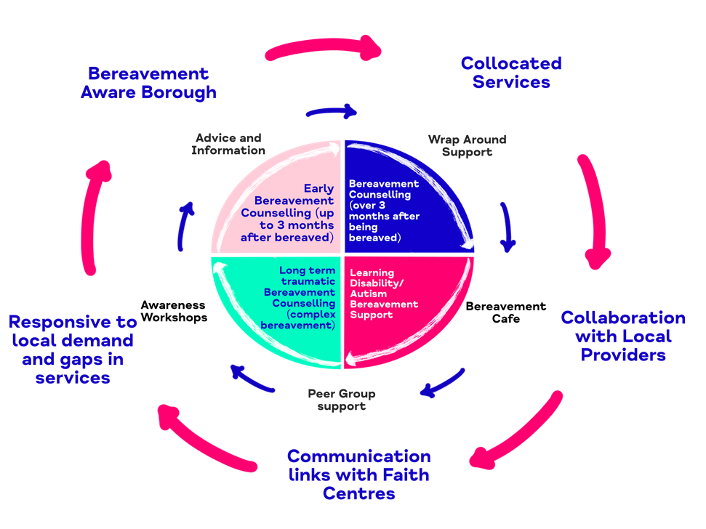

**Duties and Responsibilities**

To manage the clinical and operational provision of the Newham Bereavement Service contract and ensure that all KPI’s are met as well as support the Operations Director/CEO around future developments.

To ensure that the new model is embedded across Newham including Early Bereavement, Bereavement support for marginalised communities, development of bereavement support for LD and Autism.

To work collaboratively with the Commissioner and local providers to ensure that Newham become a Bereavement Aware Borough.

**Main tasks - Project Management and Coordination of the Newham Bereavement service**

1. **Service Development**

In conjunction with the Operational Director and CEO support the development of the Newham Bereavement Service in line with the service level agreement, BACP quality standards and National Bereavement Care Standards developed by Cruse. The standards can be found: <http://www.cruse.org.uk/bcss?gclid=CLO_6Pvm-9ICFaUW0wodCskJVw>

* Ensure that the service develops all aspects of the SLA in line with the contract including: One to one counselling
* LD and Autism
* Groups and engagement with marginalised communities

Work closely with other staff and contribute towards discussions around operational and clinical matters.

* **Coordination and management of referrals**

Undertake and oversee clinical assessments for those accessing counselling and allocate to appropriate counsellor, respective service strand or signposting to other services.

1. **Recruitment of Paid Counsellors/Volunteers/Clinical Supervisors**

To ensure that we have sufficient paid staff/volunteers/Clinical Supervisors within the service to meet the KPIs

Working closely with the Clinical Lead and Coordinators of ELFT services to be involved in the recruiting and inducting all counsellors/external supervisors in line with Mind in Tower Hamlets and Newham policies and procedures and Counselling recruitment criteria.

Effective allocation of counsellors to respective services in line with current counselling volunteer allocations procedures

Ensure that the service works in line with the BACP Ethical Framework in line with our BACP accreditation.

1. **Staff, Recruitment, Induction, management and supervision**

Recruit, Support and manage both the paid counsellors and Counselling Volunteers.

Delivery of counselling will be in line with MITHN’s Counselling Volunteer Placement model. Currently up to 8 volunteer Counsellors and 4 paid counsellors.

Coordinate and ensure that all counsellors receive bi-weekly clinical supervision

Support the group facilitator to ensure effective delivery of 6 weekly group sessions

Supervision of the Administrative assistant to enable them to offer back-office support

Provide support and management guidance to all external supervisors to ensure that our supervision provision is of a consistent standard

To ensure that the team has appropriate training and development in line with their professional qualifications

Facilitate team meetings and attend other meetings as required by this service.

1. **Bereavement Awareness and Training**

Maintain a general overview of bereavement training needs across the counselling services provision

Devise and deliver suitable bereavement training in line with good practice recommendations and requirements

Keep up to date on all matters relating to bereavement and practise and ensure that these are Communicated across the wider teams

Attend End of Life Strategy Meetings, and represent organisation on National Bereavement Alliance.

1. **Data Management**

Ensure that all staff are inducted on the use of the Views database system and that accurate records are being maintained.

Ensure service outcomes are developed, completed by clients, and reported on to the commissioners. (CORE 10 in place for one-to-one counselling, other tools will be developed in line with the SLA)

A proactive approach in project planning, delivering on targets, case management supervision and taking responsibility for understanding and disseminating service information related to target areas and the service’s key performance indicators

Ensure that each service strand is operating to full capacity and able to deliver against the agreed KPI’s.

Ensure good evaluation of the service and monitor completion levels

In conjunction with the Operational Director support the production of quarterly monitoring reports

1. **Promotion of service and Bereavement Awareness**

Ensure effective promotion, including any outreach and presentations to ensure wide access and participation from different sectors of the community

Maintain excellent communication across all areas of activity to ensure a responsive and well-run provision.

Ensure publicity material up to date and circulated across the borough.

1. **New Developments and Opportunities**

To work with the Operational Director and CEO to develop new service opportunities

To work closely with the OD and CEO to explore new opportunities to expand our services

To explore new models of working and consider these for new or existing developments

To work closely with the lead staff when tenders are written to provide the therapeutic angle required to make a bid successful.

1. **Duties required of all Mind in Tower Hamlets and Newham employees**

To work unsocial hours as required, evening and weekends as the service needs are identified

Undertake the induction programme as devised, and assist, as requested, in the induction and training of new staff, students and volunteer

Participate in staff meetings, team meetings, supervision meetings, appraisals, consultancy, training, team development sessions, working groups and other meetings as required, reporting back as required

Provide cover for staff who are absent, at the direction of the service manager.

To be administratively self-servicing, with good organisational skills

Effectively manage the income and expenditure related to the counselling service within the finance procedures laid down. To effectively manage any petty cash or financial issues within the finance procedures laid down.

Carry out other duties consistent with the post

Share responsibility for the effective use of systems and procedures for service users, finance, staff communication, and dissemination of good practice and effective working methods within Mind in Tower Hamlets and Newham

Share responsibility for health and safety practices, reporting any concerns to line management

Undertake all duties in accordance with Mind in Tower Hamlets and Newham’s policies, with reference to the Equal Opportunities and Health and Safety policies, and work towards their continuing development and implementation.

**This job will be reviewed periodically in line with the organisation’s Business Plan. Mind in Tower Hamlets and Newham aim to reach agreement on changes, but if agreement is not possible, Mind in Tower Hamlets and Newham reserves the right to change the job description**

|  |  |  |
| --- | --- | --- |
| **Person Specification - Project Manager (Newham Bereavement Service)**  Outlined below are the experience, skills and knowledge required to carry out the tasks in the job description. Please ensure that you use examples to demonstrate that you meet each individual criteria within the application form | | |
| **No** | **Qualifications** | **Essential/Desirable** |
|  | To have a Psychotherapy or Counselling qualification to advanced Diploma (level 4 minimum) or Degree level | E |
|  | Accredited membership of the UKCP / BACP or BCP or willingness to achieve accreditation | E |
|  | Evidence of significant post-qualifying continuous professional development | E |
|  | Experience in providing clinical supervision | D |
|  | Management qualification | D |
| **Experience** | | |
|  | Substantial and demonstrable experience of providing individual counselling of at least 2 years post qualification and assessments | E |
|  | Significant recent clinical experience | E |
|  | Experience of working in primary care counselling environment | E |
|  | 2 years demonstrable experience of managing a counselling service ideally around bereavement | E |
|  | Experience of recruiting and supervising staff/counsellors | E |
|  | Experience of performance management and delivering to expected targets | E |
|  | Significant experience of working with different modalities | E |
|  | Significant experience of change management, service evaluation, service improvement or contributing to business expansion | E |
|  | Experience of preparing written and verbal reports of a high standard to internal and external agencies. | E |
| **Skills and Knowledge** | | |
|  | Ability to communicate with partners/senior staff at a high level as well as regulatory bodies and maintain good relations. | E |
|  | Ability to broaden the scope of counselling to reach all sections of a multi-ethnic community in a creative manner | E |
|  | Ability to lead, manage and develop a diverse team | E |
|  | Ability to work as part of a multi-disciplinary team and with partner organisations | E |
|  | Ability to prioritise a varied workload whilst handling competing demands in a pressurised environment | E |
|  | Ability to monitor and evaluate service performance and implement measures for underperformance | E |
|  | Ability to be administratively self-servicing, good organisational, project management and IT skills | E |
|  | Understanding and experience of carrying out audit, clinical governance, and clinical effectiveness procedures | E |
| Personal Circumstance/Attributes | | |
|  | Enthusiasm, Probity, Industriousness | E |
|  | Personal resilience and flexible attitude in the face of difficulties | E |
|  | High level of self-awareness – the ability to reflect on own practice and to share personal experience. | E |
|  | Commitment to personal development and willingness to regularly update skills and experience | E |
|  | Excellent leadership skills including, listening, creativity and the ability to influence. | E |
|  | A commitment to Equity, inclusion, and diversity | E |