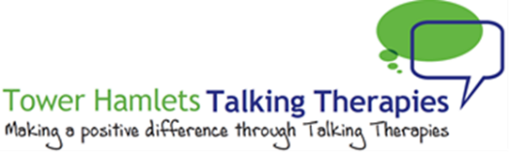

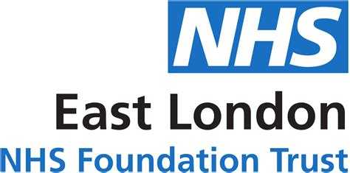

**Advert: Employment Advisor – Tower Hamlets Talking Therapies x2**

**Hours:** 35 Hours per week

**Salary:** NJC Scp16 – Scp20.  This is £27,651 to £29,630 per annum inclusive of Inner London Weighting.

**Location:** Tower Hamlets

**Contract:** Currently until 30th September 2022 (pending extension to contract)

**Closing Date: 9.00am, Monday 28th March 2022**

**Interviews: Thursday 7th April 2022**

Mind in Tower Hamlets and Newham in partnership with East London NHS Foundation Trust are seeking to recruit 2 Employment Advisors in our Tower Hamlets Talking Therapies Service.

We offer talking therapies to help people recover from common mental health difficulties such as stress anxiety and low mood. Our employment advisors work in collaboration with our team of therapists to help people in treatment to find, return and retain work.

This role is suited to someone who has a background in employment advice, human resources, legal advice or customer support.

You will have demonstrable experience of working in the voluntary/statutory sector ideally within the IAPT culture or in a primary care mental health setting.

You must have experience of case management and be able to provide one to one person centered advice and support. You will have the ability to communicate with a diverse range of people who may be experiencing difficulty with their employment situation. You should be able to demonstrate excellent administrative and IT skills including, writing reports and managing client data.

Working closely with the Employment Service Manager you will help develop the service in line with contract requirements.

The benefits of working for the organisation include 30 days annual leave, rising to 35 days after 5 years of service, training opportunities, good Company Pension Scheme, Death in Service Benefit and an Employee Assistance Programme.

Post is subject to an enhanced Disclosure Barring Service check. Applications welcome from all sections of the community.

To apply please complete the application form in this recruitment pack and email it to [recruitment@mithn.org.uk](mailto:recruitment@mithn.org.uk)