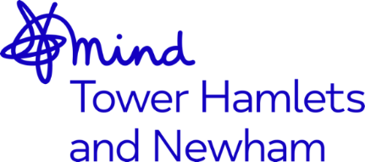


Administrator – Talking Therapy services – Job Advert
Job Title: Administrator – Talking Therapy Service
Salary: NJC scale point 7-14, currently £23,731 - £26,719, per annum inclusive of Inner London Weighting. Based on NJC 7, for 28hrs per week, this is currently £18,984.80 per annum inclusive of Inner London Weighting
Accountable to: CEO
Supervised by: Clinical Delivery Manager
Location: Open House, 13 Whitethorn St, E3 4DA
Hours: Full Time 35hrs per week with some flexible evenings
Mind in Tower Hamlets and Newham are looking to recruit an Administrator to support the Talking Therapy services across Tower Hamlets and Newham. The suitable candidate will deliver administrative support to out Talking Therapy Services team, in line with our organisational values which are: Together, Unstoppable, Independent, Openness and Responsive.
This role is suitable for someone who is passionate about working within the field of mental health, with a demonstrable and substantial experience of providing administrative support ideally within a mental health or health setting.
You will have the skills and ability to offer a front facing role using your excellent communication skills deal with client queries and other therapists and callers to the counselling service. With excellent organisational skills you will be able to demonstrate that you can prioritise and manage your own workload, keeping excellent records and have a good knowledge and application of IT systems including patient data base systems.

You will need to be an effective communicator with other professionals, colleagues and service users including those who may be experiencing distress. You will be able to work as part of a team, on your own initiative as well as under pressure.

The benefits of working for the organisation include 30 days annual leave, rising to 35 days after 5 years of service, training opportunities, good Company Pension Scheme, Death in Service Benefit and an Employee Assistance Programme.
The post is subject to an enhanced Disclosure and Barring Service check.
We welcome applications from all sections of the community.
Closing date: 9am, Monday 25th April 2022
Interview date: Wednesday, 4th May 2022

