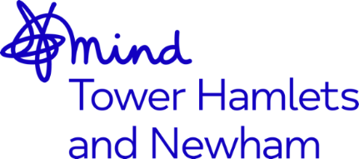


Independent Mental Health Advocate (IMHA) – Job Advert
Job Title: | Independent Mental Health Advocate
Accountable to: | CEO, Mind in Tower Hamlets and Newham
Responsible to: | Advocacy Service Coordinator, who reports to the Operational  Director of Advocacy
Working hours: | Full-time 35 hours per week
Contract Term: | Post is funded until 31 March 2023
Salary: | NJC SCP 14-20 (£26,719 - £29,360 p.a. inclusive of Inner London Weighting)  starting salary will be based on Scp 14, is £26,719
Based in: | Mile End Hospital, Tower Hamlets

Mind in Tower Hamlets and Newham are looking to recruit a qualified Independent Mental Health Advocate to join our advocacy team based in Tower Hamlets, with a passion for delivering high quality advocacy, in line with our organizational values which are: Together, Unstoppable, Independent, Openness and Responsive.
This role is suitable for someone who is passionate about working within the field of mental health, with a demonstrable and substantial experience of providing advocacy either in an in-patient or community setting.
You will have the skills and ability to prepare and deliver written and verbal reports of the highest standard to both external and internal agencies. With excellent organizational skills you will be able to demonstrate that you can prioritise and manage your own workload, keeping excellent records and writing clear and concise case notes
You will need to be an effective communicator with other professionals, colleagues and service users including those who may be experiencing distress.
You will be able to work as part of a team, on your own initiative as well as under pressure.

You must have excellent IT skills including Microsoft Office including Teams, as the post is administratively self-servicing.

The benefits of working for the organisation include 30 days annual leave, rising to 35 days after 5 years of service, training opportunities, good Company Pension Scheme, Death in Service Benefit and an Employee Assistance Programme.
The post is subject to an enhanced Disclosure and Barring Service check.
We welcome applications from all sections of the community.
Closing date: 9am, 23rd May 2022
Interview date: Friday 27th May 2022

