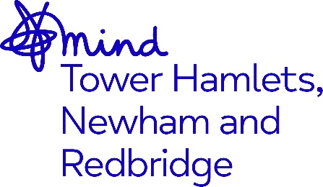

JOB ADVERT
Independent Mental Health Advocate (IMHA)

Job Title: Independent Mental Health Advocate (IMHA)
Grade: NJC SCP 11-17 £27,693 - £30,484 p.a. (inclusive of Inner London Weighting).
Hours: Full Time 37.5 hours per week
Accountable to: Operations Director for Advocacy
Supervised by: Advocacy Service Coordinator
Location: Mile End Hospital, Tower Hamlets, London E1
Contract Term: Until October 2026

Closing Date: 9.00am Monday 13th November 2023, 9am
Interviews: 23rd November 2023

Overview

Mind in Tower Hamlets, Newham and Redbridge are looking to recruit a qualified Independent Mental Health Advocate to join our advocacy team based in Tower Hamlets, with a passion for delivering high quality advocacy, in line with our organisational values which are: Together, Unstoppable, Independent, Openness and Responsive.

This role is suitable for someone who is passionate about working within the field of mental health, with a demonstrable and substantial experience of providing advocacy either in an in-patient or community setting.

You will promote self-advocacy, supporting service users’ understanding of the choices open to them, enabling them to express their views and opinions and their active involvement in the decision-making process regarding their mental health.

You will have the skills and ability to prepare and deliver written and verbal reports of the highest standard to both external and internal agencies. With excellent organisational skills you will be able to demonstrate that you can prioritise and manage your own workload, keeping excellent records and writing clear and concise case notes. You must have excellent IT skills including Microsoft Office including Teams, as the post is administratively self-servicing.

You will need to be an effective communicator with other professionals, colleagues and service users including those who may be experiencing distress. You will be able to work as part of a team, on your own initiative as well as under pressure.

Adopting our organisational culture

We have a strong reputation for delivering high quality services and achieving positive outcomes.

Our practices are underpinned by our Kindness Charter, Professional Code of Ethics, Code of Conduct and organisational values. We expect everyone to embrace our culture, ethos and our anti-racist, anti-discriminatory and inclusive practices throughout their work.

The benefits of working for the organisation include 28 days annual leave + Public Holidays, Development and Growth opportunities, Company Pension Scheme and an Employee Assistance Programme.

This post is subject to an enhanced Disclosure Barring Service check and Right to Work Checks.

As an anti-racist, anti-discriminatory and inclusive organisation, we strongly welcome applications from all sectors of the community.

Please refer to the job description and person specification for more information about this role.

To apply please send your CV together with a cover letter stating why you wish to apply and how you meet the role requirements and email to recruitment@mindthnr.org.uk

