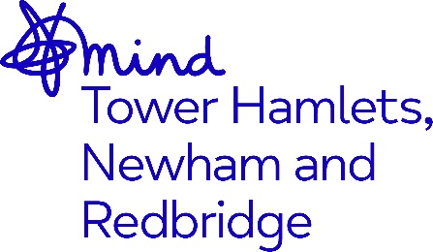

JOB ADVERT

Community Support Worker (Safe Space Café)

Job Title: Community Support Worker (x2)
Salary: NJC SCP 5 – 10, currently £25,214 - £27,259 per annum inclusive of Inner London Weighting. Based on 22.5 hours per week at NJC SCP5 is currently £15, 128.40 pa (Inc ILW)
Hours: 22.5 hours a week across 4 days (Role may require flexible working
Contract: 9-month Contract with possibility of extension
Supervised by and
Accountable to: Operations Director
Location: Based at Open House, E3 4DA (Tower Hamlets)

Closing Date: 9am Friday 20th October 2023
Interviews: Week commencing 30th October 2023

Job description

At our Safe Space Cafe, we believe in the power of connection and understanding. Join us in making a positive impact in the lives of our clients through this key role which will provide a warm welcome to all accessing mental health support.

Through high level interpersonal skills and the ability to build good relationships, you will play a crucial role in creating a welcoming and supportive environment for individuals seeking a place of solace, conversation, and connection. Your exceptional customer service skills, passion for coffee, and understanding of mental health will contribute to fostering a safe and inclusive space for all clients.

If you are passionate about providing support to individuals through a welcoming cafe environment and are dedicated to promoting mental health awareness, we encourage you to apply.

Purpose of the role

- To provide a supportive Safe Space Café as part of our warm welcome for people accessing our services
- To work collaboratively with the Connecting Communities First Point of Access service to signpost people to local services, activities, and events.
- To support people with mental health issues to develop employment skills through volunteering and work-based placements in the Safe Space Café
- To oversee trainees, apprentices and volunteers in the operations and effective management of the Safe Space Café

Adopting our organisational culture

We have a strong reputation for delivering high quality services and achieving positive outcomes.

Our practices are underpinned by our Kindness Charter, Professional Code of Ethics, Code of Conduct and organisational values. We expect everyone to embrace our culture, ethos and our anti-racist, anti-discriminatory and inclusive practices throughout their work.

Key Responsibilities

Role Specific

- Greet and welcome clients, staff and visitors with warmth and kindness
- Signpost clients to local services and events
- Prepare and provide a full range of hot and cold beverages and light snacks
- Develop opportunities for clients to become Safe Space Café volunteers and Support Café trainees, apprentices and volunteers in their role
- Work with the employment team to identify opportunities with local cafés for clients, volunteers and apprenticeship programmes and other routes to employment

General

- Comply with, promote, and contribute to the development of MindTHNR’s: Aims and
Values, Equality, Diversity and Inclusive principles and all organisational policies.
- Attend appropriate internal, external training courses, E-Learning, supervision, and staff team meetings and away days.
- Be administratively self-servicing

You must have:

- Previous experience as a barista or in customer service roles.
- Level 2/3 Food Hygiene Safety trained
- Experience of managing, supporting and training volunteers
- Till management and reconciliation
- Stock Management and control
- Strong understanding of mental health topics
- Ability to engage in sensitive conversations

Desirable:

- Passion for coffee and a desire to create exceptional coffee beverages
- Experience of developing website and delivering social media messages across a range of platforms


The benefits of working for the organisation include 28 days annual leave + Public Holidays, Development and Growth opportunities, Company Pension Scheme and an Employee Assistance Programme.

Post is subject to an enhanced Disclosure Barring Service check and Right to Work Checks.

As an anti-racist, anti-discriminatory and inclusive organisation, we strongly welcome applications from all sectors of the community.

To apply please send your CV together with a cover letter stating why you wish to apply and how you meet the role requirements and email to recruitment@mindthnr.org.uk

