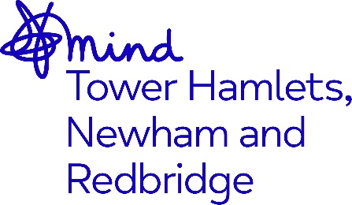

Senior Community Connector (Newham)

Advert

Job Title: Senior Community Connector

Grade/Salary: £33,075 per annum

Hours: Full Time, 37.5 hours per week (potential for part time or job share)

Accountable to: MindTHNR CEO

Supervised by: MINDTHNR Operations Director

Location: Stratford MindTHNR site, Stratford &ELFT (Primary Care Network- Newham)

Contract Term: May 2027

Closing Date: 9.00am, Wednesday 29th November 2023
Interviews: TBC - Actively interviewing

Background/context

The Community Connectors programme is an exciting partnership between Mind in Tower Hamlets, Newham and Redbridge, Community Links, Aston Mansfield, and the NHS East London Foundation Trust (ELFT). After successfully delivering the pilot since 2020, Community Links has been awarded the 5-year iteration of the Mental Health Social Prescribing programme with a total contract value of £3.8m, due to launch in June 2022.

The community connectors programme represents an integral part of the wider programme of work which supports the Transformation of Mental Health Services agenda across Newham.

The programme is grounded in a population health approach to SMI, delivered through and with Primary Care Networks in Newham, with an ambitious vision to support more patients closer to home and reduce the stigma and fragmentation in existing services.

Purpose of the role

The Senior Community Connector will have supervisory responsibility for two Community Connectors, providing guidance and day to day support, as well as managing a small caseload of people living with a serious mental illness or SMI. The Senior Community Connector will lead on work developing strong relationships with multi-disciplinary teams (MDTs) who work with primary care networks or PCNs (clusters of GP practices) across Newham. The MDTs are organised into two Community Integrated Mental Health Services (CIMHS) teams, linked to PCNs within Newham. The Senior Community Connector will help to identify themes and emerging need, develop further support pathways for service users, and be an important link between local experts and local assets.

The Senior Community Connector will be supported by the operations director to ensure the Community Connector team remains a vibrant, dynamic, and high performing team, meeting key programme aims and objectives.

The Senior Community Connector will work with ELFT as part of the Community Mental Health Transformation Programme. The ethos of the programme is recovery focused, exploring needs through complexity (rather than diagnosis), a focus on a person’s strengths and assets, and on the wider determinants of health and wellbeing.

This role will sit within the MDT, so communication with the team lead will be essential. The MDT includes primary care colleagues (GPs, social prescribers, wellbeing practitioners), as well as occupational therapists, pharmacists, nurses, peer support workers, support workers, psychiatrists, and psychologists.

Above all, the Senior Community Connector will act as an ambassador for the Community Connector team, programme, and vision – with an emphasis on ensuring strong awareness/publicity of the value that the role and programme brings to the Mental Health Transformation programme and the people it serves.

You must have:

- University degree and/or professional qualification
- Supervisory/people management/leadership experience
- Experience of working with multiple stakeholders, particularly in the voluntary, community and faith (VCF) sector
- Significant experience in local statutory and voluntary sector services
- Experience of supporting and managing a caseload or group of service users that require wrap around support.
- Experience of producing and working alongside risk assessments

The benefits of working for the organisation include 28 days annual leave + Public Holidays, Development and Growth opportunities, Company Pension Scheme and an Employee Assistance Programme.

Post is subject to an enhanced Disclosure Barring Service check and Right to Work Checks.

As an anti-racist, anti-discriminatory and inclusive organisation, we strongly welcome applications from all sectors of the community.

