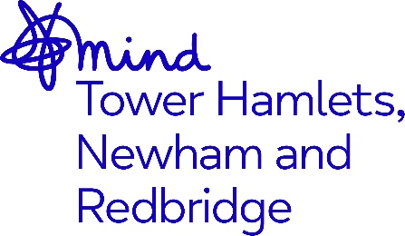

Executive Assistant and Governance Officer

Job Title: Executive Assistant and Governance Officer
Salary: circa £30,000 per annum (inc ILW) pro rata for part time
Hours: Full or part time
Contract: Permanent
Accountable to: CEO
Location: Hybrid (some presence in main office in Bow, E3)

Closing Date: Midnight Sunday 3rd November 2024
Interviews: Thursday 7th November 2024 (likely to be in person)

Job description

About us

Mind in Tower Hamlets, Newham & Redbridge (Mind THNR) is a local Mind association and community mental health charity. We endeavour to make sure that everyone with a mental health or emotional issue has somewhere to turn for advice and support.
Our vision is a society where everyone is accepted and included; where there is no stigma or discrimination towards people because of mental health issues; and where our clients' needs and ambitions are supported. We provide an extensive range of support services- including for those in crisis, through our work in Tower Hamlets, Newham and Redbridge.

Adopting our organisational culture

We have a strong reputation for delivering high quality services and achieving positive outcomes.

Our practices are underpinned by our Kindness Charter, Professional Code of Ethics, Code of Conduct and organisational values. We expect everyone to embrace our culture, ethos and our anti-racist, anti-discriminatory and inclusive practices throughout their work.

The Role
We have an exciting opportunity to join us in the brand new role of Governance and Executive Officer.
You will provide proactive and efficient secretariat and administrative support to the Executive and Non-Executive Teams, working closely with the Leadership Team to support the fulfilment of their day-to-day tasks and strategic objectives.

The role includes supporting and organising meetings and reports, and minuting of executive meetings. In addition to general PA and administrative duties, you will provide a cohesive secretariat function to support the smooth and efficient operation of the Mind THNR Board and its sub-committees.

You will work closely with the Leadership Team to set agendas, monitor action logs, and provide a high level of support to the Board. You will share collective responsibility for supporting the delivery of business objectives, through active engagement and collaboration with colleagues at all levels in the organisation

This role is flexible in terms of days and hours, although you need to attend Board meetings in person, once a quarter in the evening and committee meetings, which are also in the evening, but on line, so three evening meetings a quarter. We are based in a beautiful office in Tower Hamlets, with lots of outside space and a café, so ideally you would be present in the office two or three days a week ( if full time).
We are an equal opportunities employer; and are proud to employ a workforce that reflects the diverse communities we serve. The majority of our staff and trustees have live experienced of mental health.

How to apply
You will need to:
- Submit a comprehensive CV and supporting statement
The supporting statement should be no more than two sides of A4 and should address the criteria in the person specification. Please email your application to bernadette.keane@mindthnr.org.uk.

You should also include the contact details of two referees, one of whom must be your current or most recent employer. Referees will only be approached with your express permission.

You will also be required to provide proof of your eligibility to work in the UK.

If you have any questions about this role or you would like to discuss it before applying, please feel free to contact Bernadette Keane at bernadette.keane@mindTHNR.org.uk



