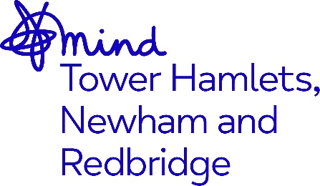

JOB ADVERT

Job Title: Children & Young People’s Counsellor - x2 Roles

Grade / Salary: NJC SCP 17 currently £30,484 (FTE) per annum inclusive of Inner London Weighting. Salary will be pro-rata based on Term Time Only and contractual weekly hours.

Hours: We are recruiting 2x post-holders, totalling 7 days per week. We are flexible with how this will be split, based on candidates’ preferences. For example, this may be split as 1x 4-day and 1x 3-day post, or 2x 3.5-day posts, etc. Please indicate your preferred hours in your application.

Supervised by: Counselling Services Manager

Location: London Borough of Newham

Contract Term: Up to 30th September 2025

Closing Date: 6th December 2024
Interviews: 19th & 20th December 2024

Job description

About Mind in Tower Hamlets and Newham
We are a local, registered charity affiliated to National Mind. The organisation supports those with mental health issues in Tower Hamlets, Newham and Redbridge towards recovery and leading a better life.

We believe that everyone has the right to access comprehensive services which enables them to reach their full potential and to work towards their recovery. We value diversity as a strength and our staff teams are from a variety of backgrounds which helps us to deliver services which are culturally aware and responsive to the needs of the diverse communities we serve.

Role Overview:
Mind in Tower Hamlets, Newham and Redbridge (MindTHNR) delivers individual and group counselling to children aged 3 – 16 and staff in a school in the London Borough of Newham.

The post holder will operate as part of a team of paid clinical counselling staff and volunteer counsellors on placement, delivering clinical interventions for children and young people within a school setting.

The Children and Young People’s counsellor will be required to conduct assessments and provide individual and group therapy to clients from a diverse range of backgrounds and support psychological wellbeing. The post holder may be required to become involved in other projects within the service, such as workshops and to work with others in areas of service development.

The post holder will deliver in-person support, on-site at the school. Occasionally remote support may be required for students based off-site, which will also be provided from the counselling rooms on-site at the school.

How to apply
Please send your CV and supporting statement outlining how you meet the criteria in the person specification to recruitment@mindthnr.org.uk

