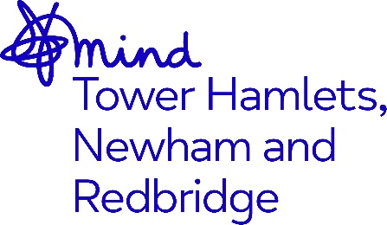

JOB ADVERT
Independent Mental Health Advocate (IMHA)

Job Title: Independent Mental Health Advocate (IMHA)

Grade: £27,693 - £30,484 p.a. (inclusive of Inner London Weighting).

Hours: Flexible- full and part time

Location: Mile End Hospital, Tower Hamlets, London E1

Contract Term:

Closing Date: 12 January
Interviews: 17 January

Overview

Mind in Tower Hamlets, Newham and Redbridge are looking to recruit a ideally qualified Independent Mental Health Advocate to join our advocacy team based in Tower Hamlets, with a passion for delivering high quality advocacy, in line with our organisational values which are: Together, Unstoppable, Independent, Openness and Responsive.

About you
Ideally you will have some experience of working in advocacy, or supporting adults who have a range of support needs, including mental ill health, physical health issues, or barriers to accessing support. You should have worked or volunteered in health, social care, welfare, support services or advice and guidance.

We are particularly interested in those with demonstrable experience of providing advocacy either in an in-patient or community setting.

You will be passionate about working within the field of mental health, and promoting self-advocacy, supporting service users’ understanding of the choices open to them, enabling them to express their views and opinions and their active involvement in the decision-making process regarding their mental health. You will work collaboratively with the individuals you support, ensuring that they have their voices heard

You will have the skills and ability to prepare and deliver written and verbal reports of the highest standard to both external and internal agencies. With excellent organisational skills you will be able to demonstrate that you can prioritise and manage your own workload, keeping excellent records and writing clear and concise case notes. You must have excellent IT skills including Microsoft Office, as the post is administratively self-servicing.

You will need to be an effective communicator with other professionals, colleagues and service users including those who may be experiencing distress. You will be able to work as part of a team, on your own initiative as well as under pressure.

You will have plenty of opportunities to enhance your professional abilities and you will make a real difference every day.

Advocates are expected to be willing to gain, or to already hold, the Level 2 Award in Independent Advocacy with disciplines suitable for the role they work in.

Adopting our organisational culture

We have a strong reputation for delivering high quality services and achieving positive outcomes.

Our practices are underpinned by our Kindness Charter, Professional Code of Ethics, Code of Conduct and organisational values. We expect everyone to embrace our culture, ethos and our anti-racist, anti-discriminatory and inclusive practices throughout their work.

The benefits of working for the organisation include 28 days annual leave + Public Holidays, development opportunities, Company Pension Scheme and an Employee Assistance Programme.

This post is subject to an enhanced Disclosure Barring Service check and Right to Work Checks.

As an anti-racist, anti-discriminatory and inclusive organisation, we strongly welcome applications from all sectors of the community.

Please refer to the job description and person specification for more information about this role.

Closing date for applications: 12 January 2025

It is essential that you read the person specification so you can tell us about yourself and how your skills, abilities and experiences match the criteria outlined in the person specification, this is how candidates will be shortlisted.

To apply please send your CV together with a cover letter stating why you wish to apply and how you meet the role requirements and email to Rashna.Begum@mindthnr.org.uk

