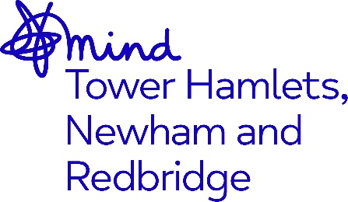

JOB ADVERT

Employment Advisor

Tower Hamlets Talking Therapies

Job Title: 3x Employment Advisor – Tower Hamlets Talking Therapies

Grade: £29,517.00 per annum, inclusive of Inner London Weighting

Hours: Full time, 37.5 hours per week

Accountable to: Head of Services

Supervised by: Employment Advice Project Manager

Location: Tower Hamlets

Contract Term: 2x Fixed-term until March 2026, and 1x fixed-term maternity cover post from February 2025 to February 2026

Closing Date: Midnight Sunday 12th January 2025
Interviews: 16th January 2025 & w/c 20th January

Job description

About Mind in Tower Hamlets, Newham and Redbridge
We are a local, registered charity affiliated to National Mind. The organisation supports those with mental health issues in Tower Hamlets, Newham and Redbridge towards recovery and leading a better life.

We believe that everyone has the right to access comprehensive services which enables them to reach their full potential and to work towards their recovery. We value diversity as a strength and our staff teams are from a variety of backgrounds which helps us to deliver services which are culturally aware and responsive to the needs of the diverse communities we serve.

Purpose of the role
The aim of this exciting role is to contribute to the delivery of Mind in Tower Hamlets, Newham and Redbridge (MITHNR) and East London Foundation NHS Trust’s (ELFT) Talking Therapies Employment Advice Service.

This role will provide employment advice to patients accessing ELFT NHS Talking Therapies, supporting patients to gain and/or retain employment via one to one information, advice and guidance sessions. This role is part of the national Employment Advice in NHS Talking Therapies programme and has been accredited by the Matrix standards for information, advice and guidance.

Key responsibilities of the role
This role will complete assessments and provide 1:1 information, advice, and guidance to a caseload of patients. Support will be based around enabling patients to find and/or retain employment, using a patient-led approach and SMART goals. Specific examples of support include CV writing, interview preparation, and broader job search techniques and approaches.

The post-holder will also be required to maintain appropriate patient records and ensure their Caseload Management Tool is continuously updated.

The post-holder will be flexible in their approach, working a hybrid model with some time spent in the office, some time spent co-locating in external premises, and some time spent working from home.

For full details of the responsibilities of this role, please refer to the Job Description and Person Specification.

Adopting our organisational culture
We have a strong reputation for delivering high quality services and achieving positive outcomes. Our practices are underpinned by our Kindness Charter, Professional Code of Ethics, Code of Conduct and organisational values. We expect everyone to embrace our culture, ethos and our anti-racist, anti-discriminatory and inclusive practices throughout their work.

The benefits of working for the organisation include 28 days annual leave + Public Holidays, Development and Growth opportunities, Company Pension Scheme and an Employee Assistance Programme.

The post is subject to an enhanced Disclosure Barring Service check, satisfactory references, and Right to Work checks.

As an anti-racist, anti-discriminatory and inclusive organisation, we strongly welcome applications from all sectors of the community.

To apply please send your CV together with a cover letter stating why you wish to apply and how you meet the role requirements detailed in the Job Description and Person Specification. Please email these to Ben.Longley@mindthnr.org.uk

